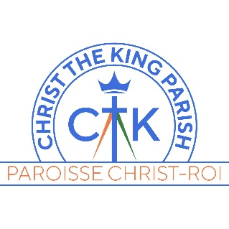
Holy Cones Ice Cream Shop
We are hiring a Manager and Assistant Manager for the 2026 summer season

Christ the King Parish is looking to hire a Manager and Assistant Manager to manage and lead the 2026 seasonal Holy Cones Ice Cream Shop located at 320 Flying Cloud Drive, Dartmouth, N.S. Holy Cones operates seven days per week from 12:00 noon to 9:00 pm, weather dependent, from late-May until Labour Day weekend in September.

Responsibilities
The Manager, supported by the Assistant Manager, is responsible for all general administrative duties related to the operation of the Ice Cream Shop by carrying out the following responsibilities:
- Daily opening, closing and securing of the ice cream shop; management of funds; and preparation of weekly schedule and timesheets of workers;
- Ensure inventory management system is kept up to date, order supplies and monitor ice cream handling procedures;
- Ensure effective customer service;
- Supervising staff members;
- Other duties as required to ensure the success of the operation.

Required qualifications:
- Currently enrolled in a post-secondary educational program with a commitment to return to studies for the Fall semester.
- Availability from mid-May to early September.

The following would be considered assets:
- Experience in managing/supervising people;
- Experience working in a client service operation;
- Experience in managing money;
- Being a parishioner of Christ the King Parish.

Key Competencies
- Customer service oriented (good sense of humour; understanding the meaning of ‘service with a smile’; keen interest in working in a team environment in a community based business; knowledge of and importance paid to good health and safety practices);
- Excellent communication skills;
- Respect for teamwork (strong team spirit; ability to build relationships with staff and customers);
- Efficient and creative problem solving skills;
- Adaptability and flexibility;
- Self motivation and dependability;
- Good leadership and organization skills;
- Attention to detail;
- Respect for people (treating all people with respect, dignity and fairness);
- Good time management skills including punctuality.

Condition of employment:
All employees over the age of 18 years must submit to both a criminal record check and a vulnerable sector check as per Archdiocesan Guidelines.

If you are interested in this position, please submit your resume and covering letter to HR@ctkdartmouth.com by no later than April 4, 2026
Please indicate clearly on your cover letter the position(s) (Manager or Assistant Manager) for which you are applying. In addition, please indicate the name of the post-secondary educational institution you are currently attending as well as confirming your return to studies in the 2026 Fall semester.

Note: a job ad for Servers will be posted at a later date.

